

ELECTRICAL AND ELECTRONICS ENGINEERING

EE464 STATIC POWER CONVERSION 2



Team Power

Asım Reha ÇETİN – Raşit GÖKMEN– Alma PİRİC

INSTRUCTOR: Ozan KEYSAN

LECTURE ASSISTANT: İlker ŞAHİN

**Table of contents**

**1.Introduction**

**2. Forward Converter Topology**

2.1 Theoretical Results

2.2 Simulation Results & Equipment Selection

**3. Controller Design**

3.1 Theoretical Results

3.2 Simulation Results

**4. Demonstration Results**

**5. References**

**1. Introduction**

In this project, we designed a forward converter which has 48V input and 24V output. It has total output power of 100 W. In addition to this forward converter, we implemented a controller which should keep output voltage same even if the output load is halved or the input voltage changed.After theoretical calculations and simulation results, we construct this forward converter on PCB.

**2. Forward Converter Topology**

Schematic of the forward converter is on the following figure 1.

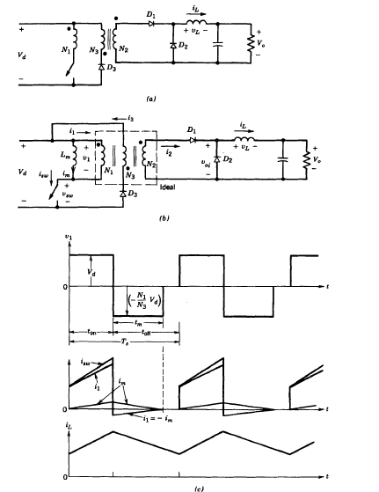

**Figure 1.** Forward converter and it’s corresponding waveforms [1]

First of all, when switch is on D1 becomes forward biased D2 becomes reverse biased. Voltage on the inductor, therefore, is

When the switch is off,

Average inductor voltage should be zero, therefore

For the forward converter, magnetizing current of the transformer should be taken into account in order to obtain proper operation. One should prevent the magnetic saturation of the core in the transformer. One way to transfer the stored energy back to the supply voltage is to use practical forward converter topology which can be seen on the figure 1.

When the switch is on

When the switch is turned off

One needs to completely demagnetize the core which means , minimum required of time is; [1]

**3. Controller Design**

**3.1 Theoretical Calculations**

Small signal analysis of the forward converter is as follows.

State equations are as follows:

On state Off state

ẋ = A1 + B1u ẋ = A2x + B2u

y= C1x y= C2x

where u is input.

Averaging them:

ẋ = [A1d +A2(1-d)] x + [B1d+B2(1-d)] u

y=C1d+C2(1-d)] x

Introducing small perturbations as follows (assuming perturbations in input is equal to zero):

x=X+x y=Y+y d=D+d

in steady state ẋ=0 and neglecting products of x and d;

ẋ=AX+Bu+Ax+[ (A1 – A2 ) X+(B1 -B2 )u]d (10-50) in text book Mohan

A = A1D + A2(1-D)

B= B1D + B2(1-D)

In steady state

AX+Bu= 0

Equation 10-50 becomes

ẋ= Ax+[ (A1 – A2 ) X+(B1 -B2 )u]d and

Y+y=CX+Cx+[(C1-C2)X]d (10-58) in text book Mohan

Where

C=C1D+C2(1-D)

Y=CX

y=Cx+[(C1-C2)X]d

Y/U=-CA-1B

Taking lap lace transform of small signal eqn. (10-58)

Y(s)/d(s)=C[sI-A]-1 [(A1-A2)X + (B1-B2)U] + (C1-C2)X

Let’s apply the formula to the forward converter state variables are defined as inductor current and capacitor voltage.

A1= [ -(R*rc + R*rl + rc*rl)/(L*(R + rc)), -R/(L*(R + rc))]

[ R/(C*(R + rc)) , -1/(C*(R + rc))]

A1=A2=A;

B1= [ 1/L ]

[ 0 ]

B2=0;

B=B1*D

For the sake of simplicity assuming R is much greater than (rc+rl);

A=A1=A2= [ -(rc + rl)/L, -1/L ]

[ 1/C , -1/(C*R)]

C=C1=C2=[rc 1];

B remains same.

A-1=1/det(A)* [-1/(C*R ) , 1/L ]

[ -1/C , -(rc + rl)/L]

Finally, steady state transfer function is

==D

Small signal transfer function is as follows

Gain crossover frequency is 70 000 (rad/s). Corresponding phase margin is relatively low. We need to design lead compensator here.

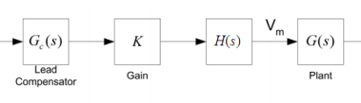

Figure xx. Lead Compensator design

H(s) is standing for elimination of steady state error and will be 1/s. K is gain.G(s) is lead compensator which has unity gain. It has a form of

We obtained characteristic of via using type 2 controller circuit. Overall open loop characteristic is

**5.References**

**[1] Mohan**